CUSTOMER SEGMENTATION WITH
MARKET BASKET ANALYSIS

INFERENCE

By : Tharun Thomas Eapen
Aaron Varguese Koshy
Introduction

We are doing this project as a part of a student internship project done at ust global .

Retail data analysis has become increasingly important for businesses aiming to understand customer behavior, optimize inventory management, and enhance sales performance. By examining transaction data, retailers can uncover purchasing patterns, identify trends, and develop strategies to meet customer needs effectively. The growing availability of detailed retail datasets has made it possible to apply advanced analytical techniques, providing businesses with a competitive edge in a dynamic market.

Main objective is on analyzing a retail dataset using machine learning and visualization techniques to extract actionable insights. The key objectives include identifying significant relationships between products through association rule mining, grouping similar products based on customer demographics using clustering algorithms, and understanding time-based purchase trends. The ultimate goal is to provide insights that can drive strategic decision-making, improve marketing efforts, and enhance overall operational efficiency.

The insights derived from this analysis can significantly impact retail operations. By identifying high-confidence association rules, businesses can optimize cross-selling opportunities and develop effective product bundling strategies. Clustering similar products enables better segmentation, improving inventory management and marketing precision. Furthermore, visualizing time-based purchasing patterns helps retailers adjust strategies to target peak demand periods, driving customer satisfaction and increasing revenue.
Dataset Description

The dataset used in this project consists of transactional and customer-related data, capturing details about products, customer purchase behavior, and order patterns. The dataset provides a comprehensive view of the retail landscape through its diverse attributes. Each record corresponds to a specific product purchased by a customer in a particular order, enabling granular analysis of purchasing trends, time-based patterns, and customer preferences.

Attributes Description
The dataset includes the following key attributes:
- Aisle ID & Aisle: These columns identify the specific aisle within the store where the product belongs, providing insights into product placement and category analysis.
- Order ID, Product ID, and User ID: These serve as unique identifiers for individual transactions, products, and customers, respectively.
- Add to Cart Order & Reorder: These attributes indicate the sequence in which products were added to the cart and whether the product was reordered, helping analyze customer loyalty and preferred items.
- Eval Set: Indicates the evaluation set (training, validation, or test), crucial for separating data for model evaluation.
- Order Number: Represents the sequence of orders placed by a customer, helpful for analyzing repeat purchasing behavior.
- Order DOW (Day of the Week) & Order Hour of Day: These time-based attributes enable the identification of peak shopping times and patterns based on specific days or hours.
- Days Since Prior Order: Indicates the gap between consecutive orders, useful for analyzing purchase frequency.
- Department ID & Product Name: These provide categorical details about the product's department and its specific name, helping in clustering and association rule mining.

Algorithms and Techniques
( running of mba for the whole data )

To achieve market basket analysis, we use the Apriori algorithm(Association Rule Mining) to identify frequent itemsets in the transaction dataset. These frequent itemsets represent combinations of items that are commonly purchased together.
After which we use association rules to derive meaningful rules that explain the relationship between the items that are frequently bought together .These rules provide insights into customer buying patterns and can inform strategies like cross-selling, promotions, and product placement .
Before running any of the algorithms we hot encode the data to fit the machine learning algorithm . For that we use TransactionEncoder .

Trial 1: Running the algorithm on Order Id, Product Sales
Features used ,
1.order_id
2.product_name
In the initial trial, the Apriori algorithm was applied using the "order_id" and "product_name" attributes to identify frequent itemsets and generate association rules. The "order_id" was used to group transactions, while the "product_name" helped capture the products purchased together in each transaction. This approach aimed to uncover purchasing patterns by analyzing how frequently certain products were bought together.
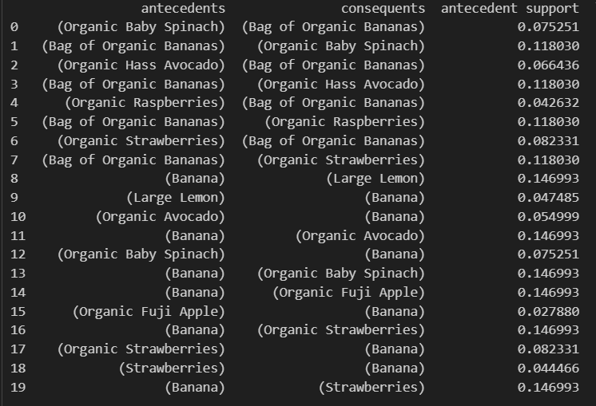
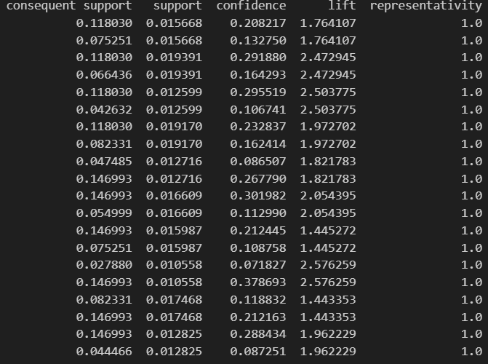
Conclusion

Fruits and vegetables are the most sold as well as the bought the most together
Organic products can be grouped together to increase the sales of those products.

.
Trial 2: Running the algorithm on attributes User Id, Product Sales
Features used ,
1.product_name
2.user_id
The "user_id" attribute grouped products based on individual customers' purchase histories, providing insights into consistent product combinations across multiple transactions. Unlike order-based analysis, this approach emphasized long-term buying habits and personalized associations unique to each customer .

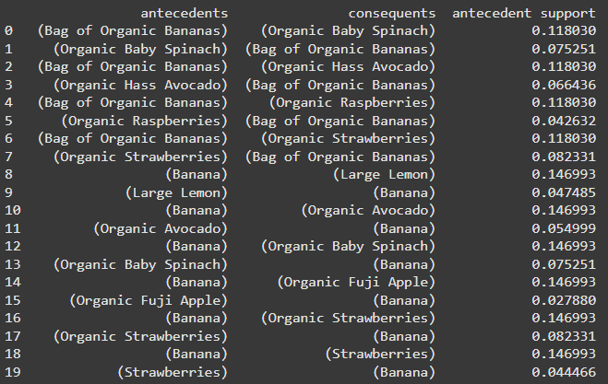
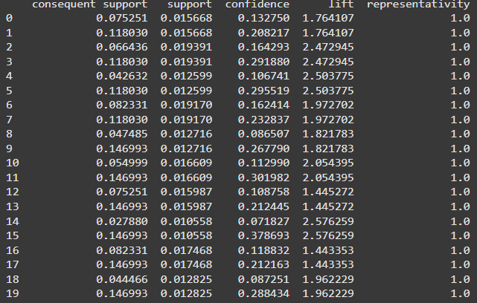

Conclusion :
Fruits and vegetables are the most sold as well as the bought the most together .
Organic products can be grouped together to increase the sales of those products.

Visualization:

Analysis with the help of Heatmap

A heatmap was generated to analyze the purchase patterns of the top 10 frequently bought items across different hours of the day.
Y axis -> top 10 most sold products
X axis ->0-23 (hours of day)
Cells -> the sales conducted in that hour for the particular product.

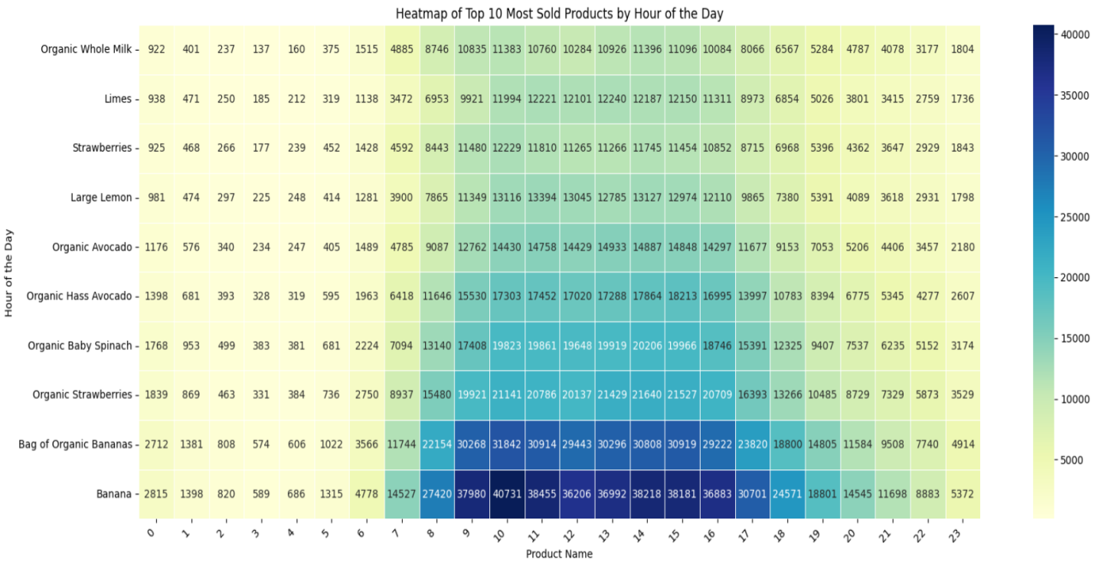

Analysis with the help of Bar Map

A few Barmaps were generated to show the top 10 most purchased items with their total sales conducted and to also show top 10 least sold items with their total sales conducted.
Y axis->Total sales quantity.
X axis->10 most or least sold items.
Both of the Barmaps are given below.

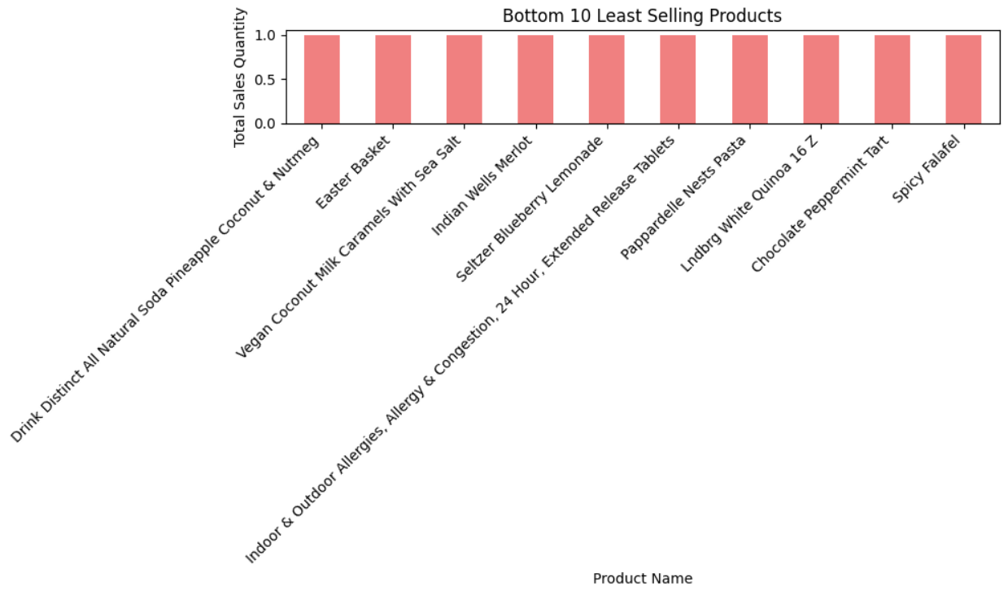
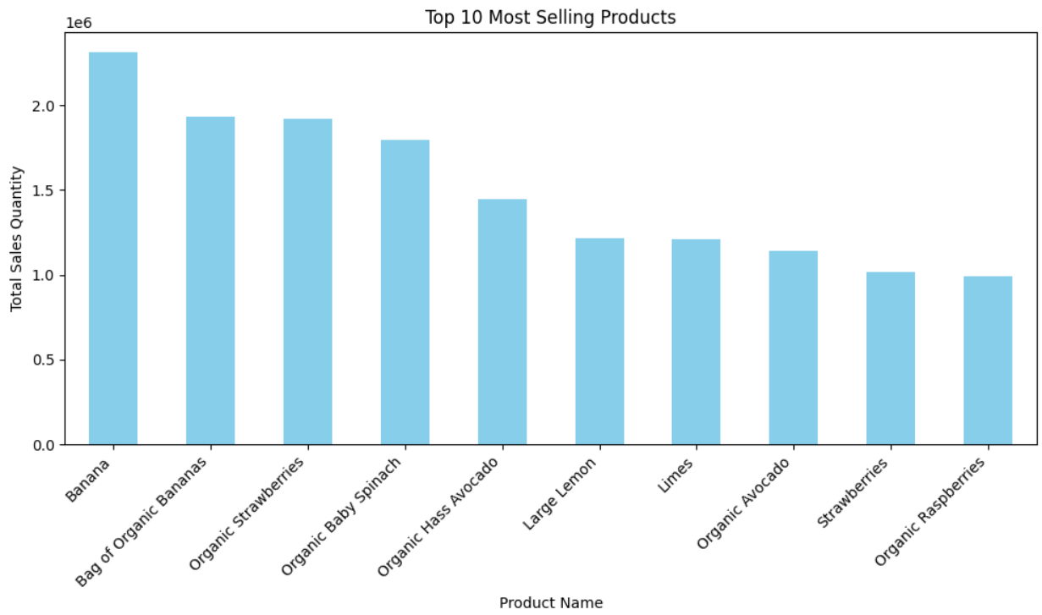

Customer Segmentation using PCA

Using Elbow Method to Find the Optimum Number of Clusters

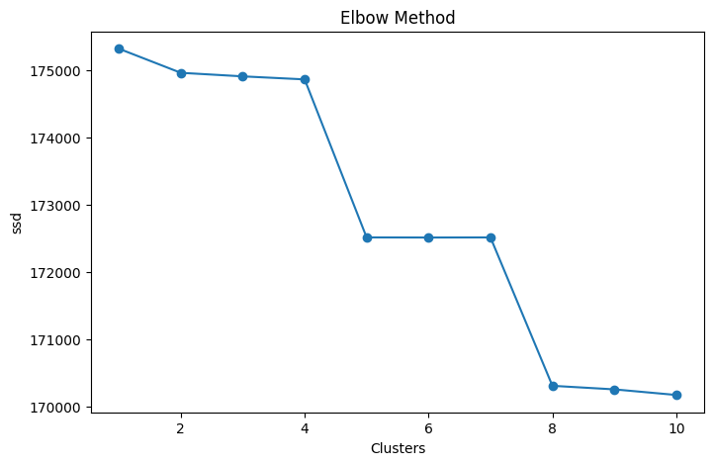

Visualizing the clusters

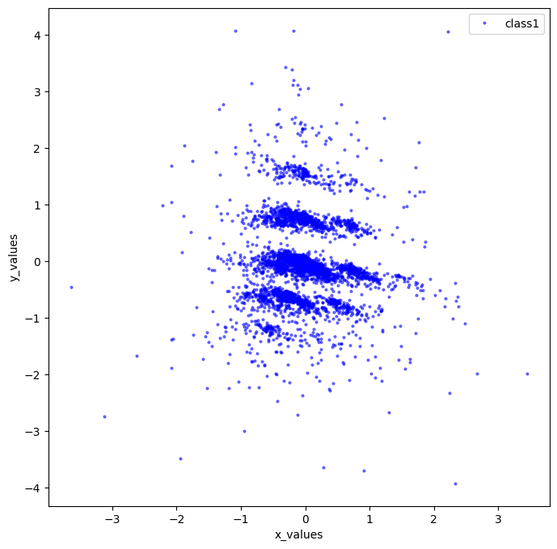
Segmenting into 4 clusters:
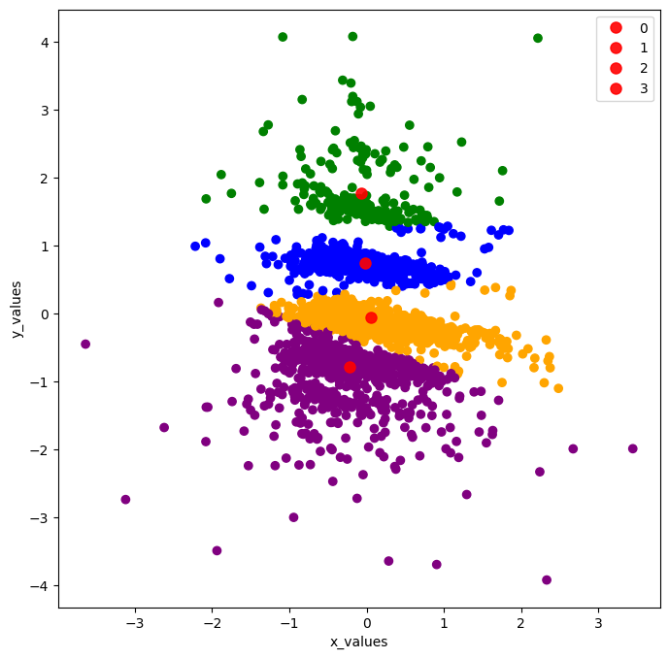
Cluster 0 : (69.11% of the customers)

Top Products

product_name
Organic Strawberries 0.084884
Organic Hass Avocado 0.063833
Organic Baby Spinach 0.062746
Organic Avocado 0.049436
Limes 0.046720
Large Lemon 0.045498
Strawberries 0.043189
Organic Raspberries 0.042917
Organic Whole Milk 0.040744
Organic Yellow Onion 0.038300
--------------------------------------------------------------------------------------------------------------------------------------------------------
product_name
Organic Strawberries 625
Organic Hass Avocado 470
Organic Baby Spinach 462
Organic Avocado 364
Limes 344
Large Lemon 335
Strawberries 318
Organic Raspberries 316
Organic Whole Milk 300
Organic Yellow Onion 282
Organic Blueberries 277
Organic Garlic 272
Cucumber Kirby 227
Organic Zucchini 224
Organic Lemon 214
Sparkling Water Grapefruit 200
Organic Grape Tomatoes 198
Organic Half & Half 195
Half & Half 184
Organic Cucumber 184
--------------------------------------------------------------------------------------------------------------------------------------------------------
Frequently Bought Products

antecedents consequents antecedent support
0 (Organic Garlic) (Organic Yellow Onion) 0.035312
1 (Organic Yellow Onion) (Organic Garlic) 0.037213
2 (Organic Strawberries) (Organic Hass Avocado) 0.074969
3 (Organic Hass Avocado) (Organic Strawberries) 0.058672
4 (Organic Strawberries) (Organic Raspberries) 0.074969
5 (Organic Raspberries) (Organic Strawberries) 0.038979

consequent support support confidence lift representativity
0 0.037213 0.010050 0.284615 7.648259 1.0
1 0.035312 0.010050 0.270073 7.648259 1.0
2 0.058672 0.012631 0.168478 2.871540 1.0
3 0.074969 0.012631 0.215278 2.871540 1.0
4 0.038979 0.010322 0.137681 3.532217 1.0
5 0.074969 0.010322 0.264808 3.532217 1.0
—-----------------------------------------------------------------------------------------------------------------------------------------

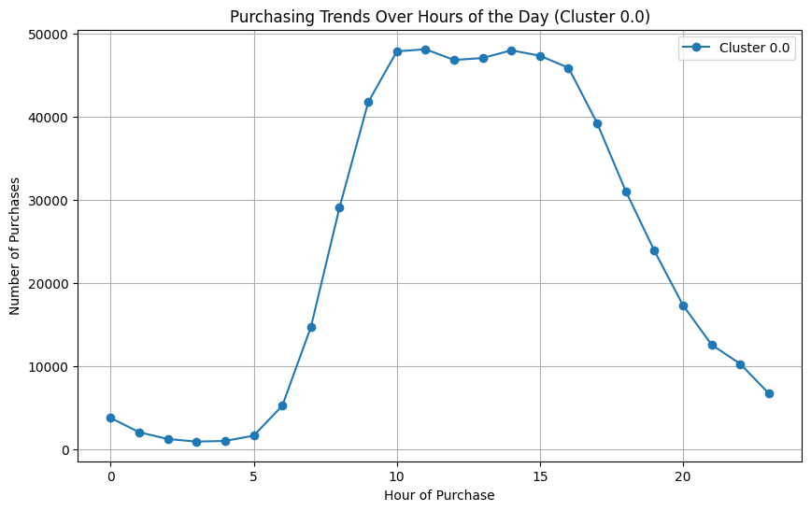

Insights

- Cluster 0 accounts for the majority of the customer base ( i e. 69.11% )
- The only cluster that does not have any type of bananas in their top 10 most purchased products
- These customers are characterised by their purchase of half and half (half whole milk and half cream)
- These customers lay an emphasis on a healthy lifestyle as seen by their purchase of organic products.
- The most bought product in cluster 0 is Organic strawberries followed by organic hass avocado.

- Bundle Organic Strawberries, Organic Raspberries, and Organic Hass Avocado.
- Create seasonal promotions focusing on top products, such as a "Spring Salad Kit" featuring Organic Spinach, Strawberries, and Avocado.
- Suggest Limes and Large Lemons as complementary items when customers purchase avocados or berries ( for guacamole or fruit salads).

Cluster 1 : ( 14.29 % of the customers )

Top Products

product_name
Banana 1.014445
Organic Baby Spinach 0.143795
Organic Strawberries 0.138542
Organic Avocado 0.135916
Strawberries 0.110309
Large Lemon 0.102429
Limes 0.090611
Cucumber Kirby 0.089954
Organic Fuji Apple 0.084045
Organic Hass Avocado 0.084045
-------------------------------------------------------------------------------------------------------------------------------------------------------------------------
product_name
Banana 1545
Organic Baby Spinach 219
Organic Strawberries 211
Organic Avocado 207
Strawberries 168
Large Lemon 156
Limes 138
Cucumber Kirby 137
Organic Fuji Apple 128
Organic Hass Avocado 128
Organic Whole Milk 115
Honeycrisp Apple 107
Organic Raspberries 93
Seedless Red Grapes 89
Blueberries 88
Organic Garlic 85
Yellow Onions 84
Michigan Organic Kale 78
Organic Zucchini 73
Apple Honeycrisp Organic 73
--------------------------------------------------------------------------------------------------------------------------------------------------------

Frequently Bought Products

antecedents
0 (Banana)
1 (100% Recycled Paper Towels)
2 (Banana)
3 (100% Whole Wheat Bread)
4 (2% Reduced Fat Milk)
5 (Banana)
6 (Banana)
7 (Apple Honeycrisp Organic)
8 (Organic Avocado)
9 (Apple Honeycrisp Organic)
10 (Organic Strawberries)
11 (Apple Honeycrisp Organic)
12 (Large Lemon)
13 (Asparagus)
14 (Organic Avocado)
15 (Asparagus)
16 (Organic Baby Spinach)
17 (Asparagus)
18 (Asparation/Broccolini/Baby Broccoli)
19 (Banana)

consequents antecedent support
0 (100% Recycled Paper Towels) 0.996717
1 (Banana) 0.017072
2 (100% Whole Wheat Bread) 0.996717
3 (Banana) 0.038083
4 (Banana) 0.023638
5 (2% Reduced Fat Milk) 0.996717
6 (Apple Honeycrisp Organic) 0.996717
7 (Banana) 0.042679
8 (Apple Honeycrisp Organic) 0.122127
9 (Organic Avocado) 0.042679
10 (Apple Honeycrisp Organic) 0.128693
11 (Organic Strawberries) 0.042679
12 (Asparagus) 0.095863
13 (Large Lemon) 0.043992
14 (Asparagus) 0.122127
15 Organic Avocado) 0.043992
16 (Asparagus) 0.126724
17 (Organic Baby Spinach) 0.043992
18 (Banana) 0.019698
19 (Asparation/Broccolini/Baby Broccoli) 0.996717

consequent support support confidence lift representativity
0 0.017072 0.017072 0.017128 1.003294 1.0
1 0.996717 0.017072 1.000000 1.003294 1.0
2 0.038083 0.038083 0.038208 1.003294 1.0
3 0.996717 0.038083 1.000000 1.003294 1.0
4 0.996717 0.023638 1.000000 1.003294 1.0
5 0.023638 0.023638 0.023715 1.003294 1.0
6 0.042679 0.042679 0.042819 1.003294 1.0
7 0.996717 0.042679 1.000000 1.003294 1.0
8 0.042679 0.012475 0.102151 2.393466 1.0
9 0.122127 0.012475 0.292308 2.393466 1.0
10 0.042679 0.014445 0.112245 2.629984 1.0
11 0.128693 0.014445 0.338462 2.629984 1.0
12 0.043992 0.013132 0.136986 3.113883 1.0
13 0.095863 0.013132 0.298507 3.113883 1.0
14 0.043992 0.010506 0.086022 1.955384 1.0
15 0.122127 0.010506 0.238806 1.955384 1.0
16 0.043992 0.012475 0.098446 2.237801 1.0
17 0.126724 0.012475 0.283582 2.237801 1.0
18 0.996717 0.019698 1.000000 1.003294 1.0
19 0.019698 0.019698 0.019763 1.003294 1.0
—-----------------------------------------------------------------------------------------------------------------------------------------

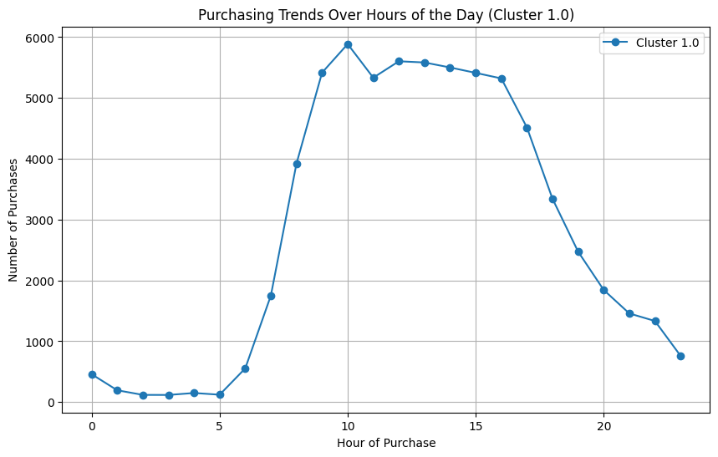
Insights

- Cluster 1 accounts for 14.3% of the customer base.
- Ingredients for items like smoothies and shakes like strawberries, bananas etc are mostly purchased in this cluster. So we can use recipe cards to suggest healthy meal options like smoothie bowls, salads, and sandwiches using these key ingredients.
- When a customer purchases Bananas, suggest Whole Wheat Bread, Organic Avocados, or Strawberries as related items.
- Suggest Large Lemon and Limes with items like Asparagus and Organic Hass Avocado for cooking or garnishing ideas.

Cluster 2 : ( 14.025% of the customers )

Top Products :

product_name
Bag of Organic Bananas 1.172021
Organic Baby Spinach 0.253012
Organic Hass Avocado 0.252343
Organic Strawberries 0.238956
Organic Raspberries 0.147925
Organic Yellow Onion 0.117805
Organic Zucchini 0.110442
Organic Whole Milk 0.110442
Organic Lemon 0.107764
Organic Garlic 0.107764
—-----------------------------------------------------------------------------------------------------------------------------------------
product_name
Bag of Organic Bananas 1751
Organic Baby Spinach 378
Organic Hass Avocado 377
Organic Strawberries 357
Organic Raspberries 221
Organic Yellow Onion 176
Organic Zucchini 165
Organic Whole Milk 165
Organic Lemon 161
Organic Garlic 161
Organic Avocado 146
Organic Blueberries 146
Organic Large Extra Fancy Fuji Apple 144
Organic Cucumber 135
Organic Gala Apples 130
Limes 124
Organic Small Bunch Celery 120
Apple Honeycrisp Organic 116
Large Lemon 113
Strawberries 110
—-----------------------------------------------------------------------------------------------------------------------------------------

Frequently Bought Products

antecedents consequents
0 (Bag of Organic Bananas) (100% Whole Wheat Bread)
1 (100% Whole Wheat Bread) (Bag of Organic Bananas)
2 (Organic Baby Spinach) (Apple Honeycrisp Organic)
3 (Apple Honeycrisp Organic) (Organic Baby Spinach)
4 (Organic Cucumber) (Apple Honeycrisp Organic)
5 (Apple Honeycrisp Organic) (Organic Cucumber)
6 (Organic D'Anjou Pears) (Apple Honeycrisp Organic)
7 (Apple Honeycrisp Organic) (Organic D'Anjou Pears)
8 (Organic Hass Avocado) (Apple Honeycrisp Organic)
9 (Apple Honeycrisp Organic) (Organic Hass Avocado)
10 (Organic Lemon) (Apple Honeycrisp Organic)
11 (Apple Honeycrisp Organic) (Organic Lemon)
12 (Organic Raspberries) (Apple Honeycrisp Organic)
13 (Apple Honeycrisp Organic) (Organic Raspberries)
14 (Organic Strawberries) (Apple Honeycrisp Organic)
15 (Apple Honeycrisp Organic) (Organic Strawberries)
16 (Organic Yellow Onion) (Apple Honeycrisp Organic)
17 (Apple Honeycrisp Organic) (Organic Yellow Onion)
18 (Organic Zucchini) (Apple Honeycrisp Organic)
19 (Apple Honeycrisp Organic) (Organic Zucchini)

antecedent support consequent support support confidence lift
0 0.974565 0.030790 0.030790 0.031593 1.026099
1 0.030790 0.974565 0.030790 1.000000 1.026099
2 0.204150 0.071620 0.018072 0.088525 1.236035
3 0.071620 0.204150 0.018072 0.252336 1.236035
4 0.078983 0.071620 0.011379 0.144068 2.011563
5 0.071620 0.078983 0.011379 0.158879 2.011563
6 0.040161 0.071620 0.010040 0.250000 3.490654
7 0.071620 0.040161 0.010040 0.140187 3.490654
8 0.204150 0.071620 0.029451 0.144262 2.014279
9 0.071620 0.204150 0.029451 0.411215 2.014279
10 0.093708 0.071620 0.014056 0.150000 2.094393
11 0.071620 0.093708 0.014056 0.196262 2.094393
12 0.127845 0.071620 0.019411 0.151832 2.119978
13 0.071620 0.127845 0.019411 0.271028 2.119978
14 0.201473 0.071620 0.024766 0.122924 1.716335
15 0.071620 0.201473 0.024766 0.345794 1.716335
16 0.104418 0.071620 0.010710 0.102564 1.432063
17 0.071620 0.104418 0.010710 0.149533 1.432063
18 0.093039 0.071620 0.012048 0.129496 1.808109
19 0.071620 0.093039 0.012048 0.168224 1.808109
—-----------------------------------------------------------------------------------------------------------------------------------------

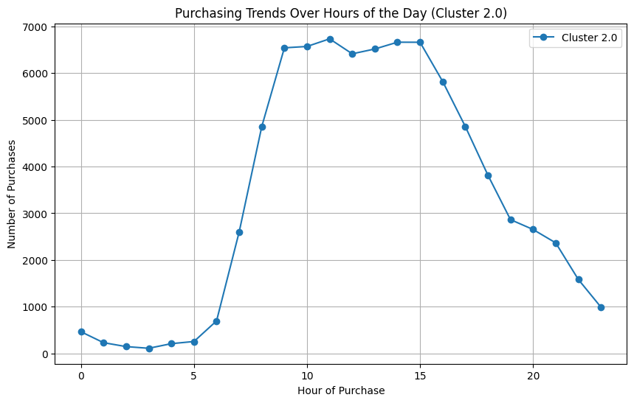

Insights

- This customer segment is characterized by their purchase of organic products , with a heavy emphasis on organic bananas .
- This customer base can be considered to be health centric .
- Organic D'Anjou Pears ↔ Apple Honeycrisp Organic shows the highest lift (3.49), revealing a distinct preference for pairing these two fruits. Organic Lemon and Organic Zucchini have moderate lifts (~2), showing solid complementary trends with Apple Honeycrisp Organic. So offers on these frequently bought products can be beneficial .
- We can place a Bag of Organic Bananas alongside 100% Whole Wheat Bread to boost sales of both products and also organize displays around Apple Honeycrisp Organic to highlight its strong associations with other organic items.

Cluster 3 : ( 2.56% of the customers )

Top Products :

product_name
Banana 2.293040
Organic Avocado 0.293040
Organic Strawberries 0.241758
Large Lemon 0.234432
Organic Baby Spinach 0.227106
Strawberries 0.219780
Honeycrisp Apple 0.201465
Organic Hass Avocado 0.179487
Organic Whole Milk 0.175824
Cucumber Kirby 0.172161
—-----------------------------------------------------------------------------------------------------------------------------------------
product_name
Banana 626
Organic Avocado 80
Organic Strawberries 66
Large Lemon 64
Organic Baby Spinach 62
Strawberries 60
Honeycrisp Apple 55
Organic Hass Avocado 49
Organic Whole Milk 48
Cucumber Kirby 47
Organic Fuji Apple 43
Limes 43
Seedless Red Grapes 39
Blueberries 38
Yellow Onions 36
Original Hummus 35
Apple Honeycrisp Organic 34
Organic Grape Tomatoes 31
Organic Raspberries 30
Boneless Skinless Chicken Breasts 29
—-----------------------------------------------------------------------------------------------------------------------------------------

antecedents consequents
0 (Banana) (1% Low Fat Milk)
1 (1% Low Fat Milk) (Banana)
2 (Banana) (100 Calorie Per Bag Popcorn)
3 (100 Calorie Per Bag Popcorn) (Banana)
4 (100 Calorie Per Bag Popcorn) (Strawberries)
5 (Strawberries) (100 Calorie Per Bag Popcorn)
6 (Banana) (100% Raw Coconut Water)
7 (100% Raw Coconut Water) (Banana)
8 (100% Raw Coconut Water) (Organic Yellow Onion)
9 (Organic Yellow Onion) (100% Raw Coconut Water)
10 (Banana) (100% Recycled Paper Towels)
11 (100% Recycled Paper Towels) (Banana)
12 (Limes) (100% Recycled Paper Towels)
13 (100% Recycled Paper Towels) (Limes)
14 (Organic Avocado) (100% Recycled Paper Towels)
15 (100% Recycled Paper Towels) (Organic Avocado)
16 (100% Recycled Paper Towels) (Organic Baby Spinach)
17 (Organic Baby Spinach) (100% Recycled Paper Towels)
18 (100% Recycled Paper Towels) (Organic Grape Tomatoes)
19 (Organic Grape Tomatoes) (100% Recycled Paper Towels)

antecedent support consequent support support confidence lift
0 1.000000 0.010989 0.010989 0.010989 1.000000
1 0.010989 1.000000 0.010989 1.000000 1.000000
2 1.000000 0.021978 0.021978 0.021978 1.000000
3 0.021978 1.000000 0.021978 1.000000 1.000000
4 0.021978 0.179487 0.010989 0.500000 2.785714
5 0.179487 0.021978 0.010989 0.061224 2.785714
6 1.000000 0.018315 0.018315 0.018315 1.000000
7 0.018315 1.000000 0.018315 1.000000 1.000000
8 0.018315 0.076923 0.010989 0.600000 7.800000
9 0.076923 0.018315 0.010989 0.142857 7.800000
10 1.000000 0.029304 0.029304 0.029304 1.000000
11 0.029304 1.000000 0.029304 1.000000 1.000000
12 0.128205 0.029304 0.010989 0.085714 2.925000
13 0.029304 0.128205 0.010989 0.375000 2.925000
14 0.201465 0.029304 0.010989 0.054545 1.861364
15 0.029304 0.201465 0.010989 0.375000 1.861364
16 0.029304 0.164835 0.014652 0.500000 3.033333
17 0.164835 0.029304 0.014652 0.088889 3.033333
18 0.029304 0.095238 0.010989 0.375000 3.937500
19 0.095238 0.029304 0.010989 0.115385 3.937500

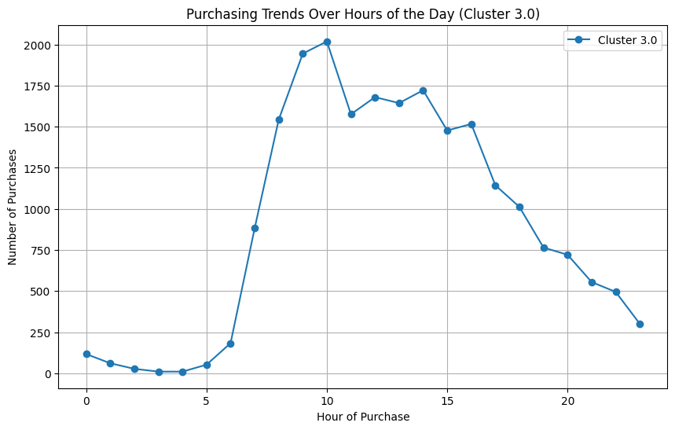

Insights
- High Association Strengths: Items like "100% Raw Coconut Water" and "Organic Yellow Onion" showed strong confidence (0.600) and lift (7.800), indicating a strong likelihood of being purchased together.
- Frequent Pairings: Products such as "100% Recycled Paper Towels" and "Organic Baby Spinach" demonstrated moderate confidence (0.500) and lift (3.033), suggesting a recurring association.
- Various product combinations, including everyday essentials like "Banana" with other items, highlight potential cross-selling opportunities.

